Time Domain Analysis: LTID Systems

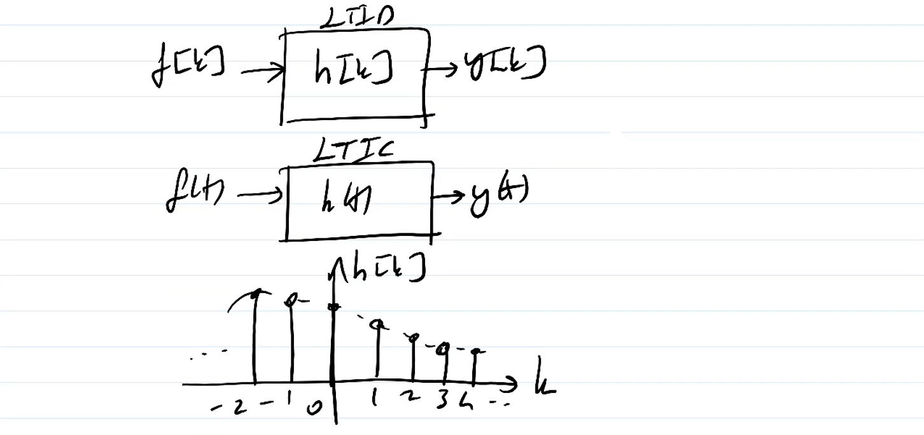

f[k] : discrete signal

y[k] : discrete signal

h[k] : discrete function (impulse response)

LTID System Equations:

* CT: Differential equations
* DT: Difference equations

Generally, a nth order difference equation:

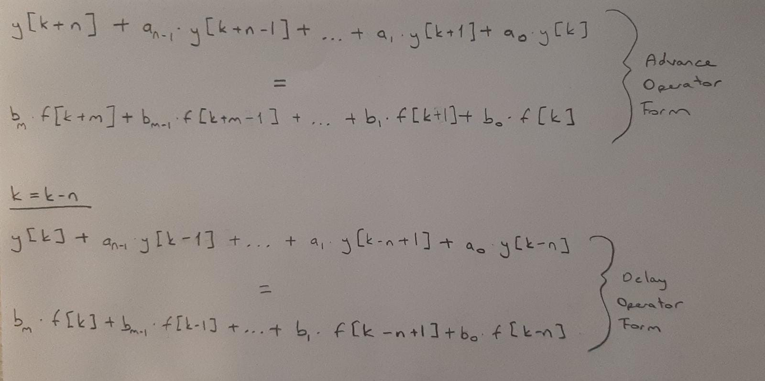

We are gonna consider advance operator form.

In CT systems 🡪 we use D = d/dt (differentiation)

In DT systems 🡪 we use E = d/dt (for advancing the by one time interval)

E1f[k] = f[k+1]

…

Enf[k] = f[k+n]

Example:

A general nth order difference equation can be expressed as:

Q(E) . y[k] = P(E) . f[k]

where:

* Q(E) = En + an-1 . En-1 + … + a1 . E + a0
* P(E) = bm . Em + bm-1 . Em-1 + … + b1 . E + b0

RECALL: Total response = zero-input response + zero-state response

Zero-Input Response

ZIR y0[k] is the solution when f[k] = 0

Q(E) . y0[k] = 0

(En + an-1 . En-1 + … + a1 . E + a0) . y0[k] = 0

*Non-Repeated Roots:*

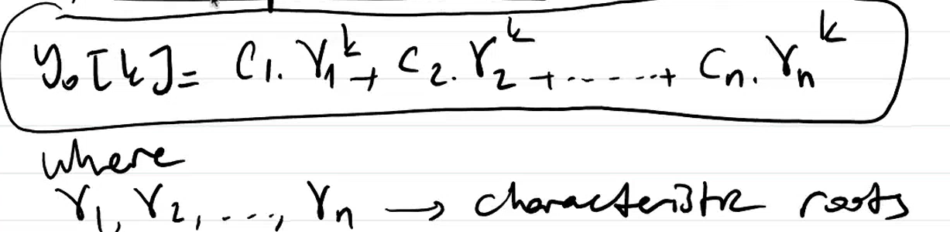

c1, c2, …, cn 🡪 arbitrary constants determined by initial conditions

(i = 1, 2, …, n) 🡪 characteristic modes

*Repeated Roots:*

If characteristic function is given by Q() = ( - 1)r, THEN y[k] is:

Example: Non-repeated roots:

For the LTID system, find y0[k] = ?

Solution:

Example: Repeated Roots:

Solution:

Unit Impulse Response h[k]

The closed form solution of h[k]:

u[k] : unit step function

Example:

Determine h[k] for the following LTID system,

y[k+2] – 0.6y[k+1] – 0.16y[k] = 5f[k+2]

h[0] = 5, h[1] = 3

Solution:

Initial conditions are given in terms of h[k] so we need to find h[k].

a0 🡪 y[k] olan tarafın E’siz değeri

b0 🡪 f[k] olan tarafın E’siz değeri

Zero-State Response

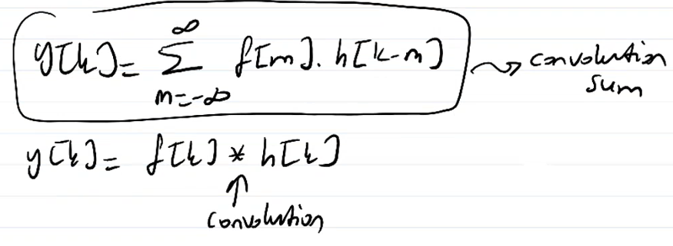

Since this is discrete time system, this is convolution sum, not convolution integral.

3 ways to find 0-state response: analytical, table, and visual methods.

***Some Properties of Convolution Sum***

The commutative property:

* f1[k] * f2[k] = f2[k] * f1[k]

The distributive property:

* f1[k] * (f2[k] + f3[k]) = f1[k] * f2[k] + f1[k] * f3[k]

The associative property:

* f1[k] * (f2[k] * f3[k]) = (f1[k] * f2[k]) * f3[k]

The shifting property:

* if f1[k] * f2[k] = c[k]
* then f1[k-m] * f2[k-n] = c[k-m-n]

The convolution with an impulse:

* f[k] $δ$* [k] = f[k]

The width property

* f1[k] 🡪 m elements

Then c[k] 🡪 (m+n-1) elements (c[k]: convolution of f1 and f2)

* f2[k] 🡪 n elements

Example (analytical method):



Solution:

**CONVOLUTION SUM FROM A TABLE METHOD (IMPORTANT!!!)**

See table 3.1 in your textbook. See property #4.

Solution is already in the table.

Total Response

Graphical Procedure for the Convolution Sum

Example:

f[k] = (0.8)k , h[k] = (0.3)k

c[k] = f[k] * h[k] = ?

Solution:

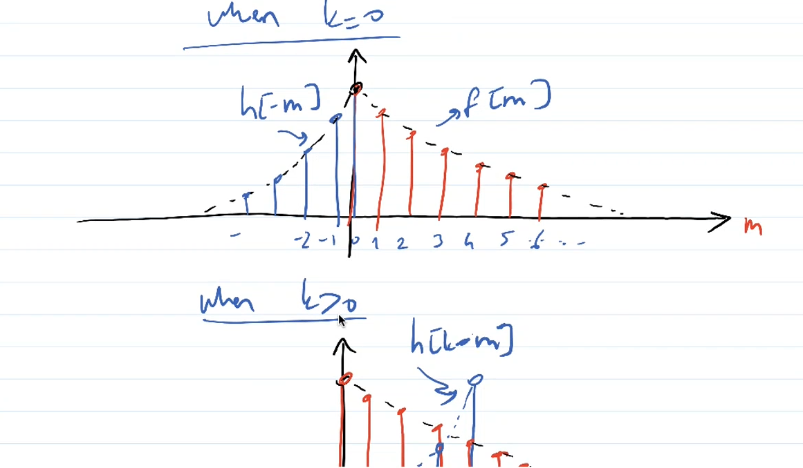

You multiply red values with blue values and add them up for different value of k according to the definition.

When k = 0, You multipliy all overlapped values and add them up, you end up with 1…

System Stability

1. Asymptotoically Stable: If all i are inside the unit circle.
2. Unstable: If
   1. At least one i is outside of the unit circle OR
   2. There are repeated roots on the unit circle
3. Marginally Stable: If no roots ($λ_{i}$) outside of the unit circle AND there are some non-repeated roots on the unit circle.

|| 🡪 magnitude

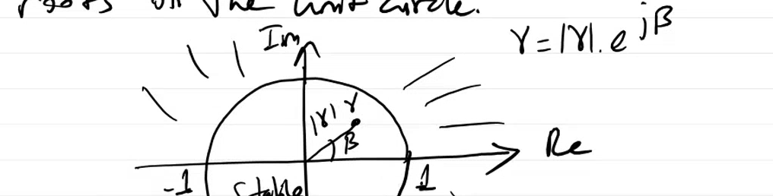

Example:

